**UiPath ServiceNow Integration**

1. **Objective:** Automate the process of handling loan requests raised in ServiceNow, including applying for a loan on the loan website, updating input Excel, closing tickets, and notifying administrators in email.
2. **Scope:** The automation will cover the entire process from handling loan requests in ServiceNow to updating input data and closing tickets.

**3. Process Flow**

**Step 1: Incident Creation in ServiceNow.** Admin raise loan requests in ServiceNow and attached the inputs in Attachment.

**Step 2: Bot Execution:** The bot monitors ServiceNow for new loan incidents. This has been achieved using **Service Now Connection Trigger in Integration Service**.

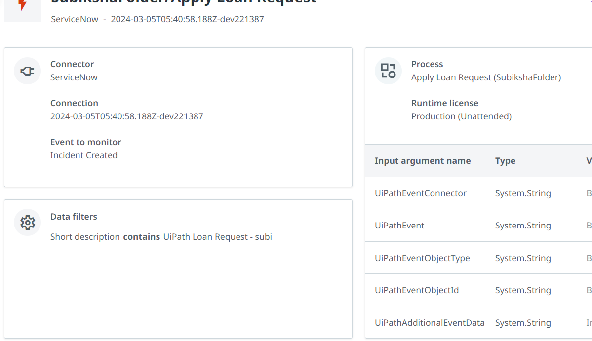

**Step – 3: Get the Attachment Sys ID:**

The Attachment file contains the input data require to raise loan request.

To Download Attachment file, we must have attachment sys_id. By executing sys_attachment API, we can get sys_id for attachment.

**API format**

https://<Service Now Instance>/api/now/table/sys_attachment? sysparm_query=table_name=incident^table_sys_id=<incident_sys_id>

Method : GET.

**Step-4: Download Attachment File :**

Once Get the attachment sys_id, use **Get Attachment** activity to download input request file (LoanRequest.xlsx)

**Step – 5:Process the input Data** :

Process the input data with typical UI Automation and update the output in same LoanRequest.xlsx file**.**

**Step – 6 : Update Admin via email:**

Update the Admin. Once Process is successfully completed.

In Case Failure, Update the admin to process manually.

**Step – 7 :**

Close the ticket, If the process completed successfully by using **Update Service Now Record Activity.**

In Case Failure, Update the work notes that the request is moved to manual intervention